Ex No.05 | User defined function | Reg. No: URK24CS9068
14.02.25

Q2. Write a python program to check whether a number is perfect or not using a function.
Aim: To check whether a given number is a perfect number using a Python function.
Objective: To understand and apply the concept of proper divisors to identify perfect numbers using Python.
Algorithm:
Step 1: Start
Step 2: Define a function that accepts a number
Step 3: Initialize a variable to store the sum of divisors
Step 4: Loop from 1 to the number (excluding the number)
Step 5: If a number divides the given number exactly, add it to the sum
Step 6: After the loop, compare the sum with the original number
Step 7: Print whether the number is perfect or not
Step 8: End
Program:
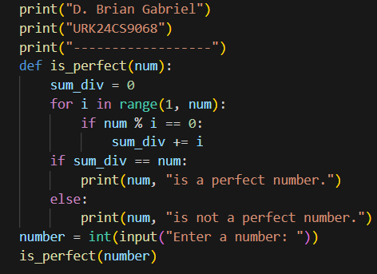
Output:
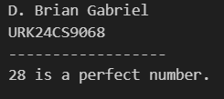
Result: The program correctly checks whether a number is perfect using its proper divisors.

Q4. Write a Python program to check whether a number is a Happy Number or not.
Aim: To check whether a given number is a Happy Number using Python.
Objective: To understand and apply the logic of digit square sum iterations to determine Happy Numbers in Python.
Algorithm:
Step 1: Start
Step 2: Define a function to find the sum of squares of digits
Step 3: Repeat the process until the number becomes 1 (happy) or loops (unhappy)
Step 4: Use a set to track seen numbers to detect cycles
Step 5: If 1 is reached, print Happy Number; if 4 or a repeat occurs, print Unhappy Number
Step 6: End
Program:
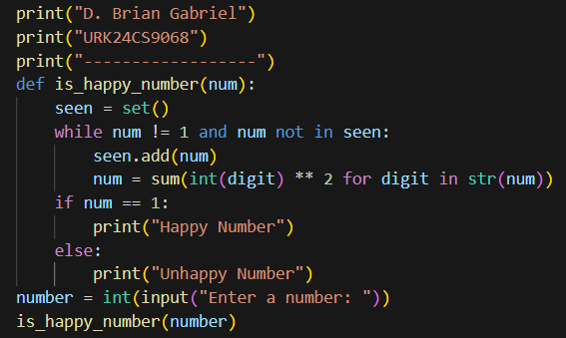
Output:
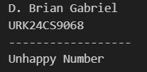
Result: The program correctly checks whether a number is a Happy Number by summing the squares of its digits repeatedly.

Q6. Write a Python function to use the arbitrary function by getting a sequence of numbers as input
and only print the divisors of the last input from the passing numbers.
Aim: To write a Python program that accepts a list of numbers and prints all the divisors of the last number in the list.
Objective: To understand how to work with lists and loops in Python to find divisors of a number using user-defined functions.
Algorithm:
Step 1: Start
Step 2: Define a function that accepts a list of numbers
Step 3: Extract the last number in the list using numbers[-1]
Step 4: Loop from 1 to the last number
Step 5: If the last number is divisible by the current loop index, print the index
Step 6: Repeat for each input list
Step 7: End
Program:
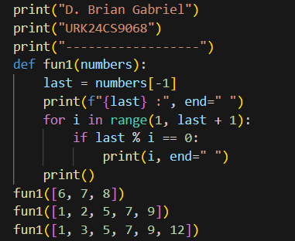
Output:
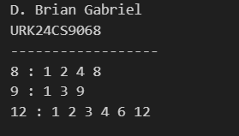
Result: The program successfully prints the divisors of the last number in a list using a function that accepts a sequence of numbers.

